DBMS PROJECT PHASE 3 – NORMALISATION
Vehicle Service Management System
Group Members:
S SANJANA [AM.SC.U4AID24036]
SURYA SURESH [AM.SC.U4AID24045]
VAISHNAVI KS [AM.SC.U4AID24048]
SREEKANTH S [AM.SC.U4AID24066]

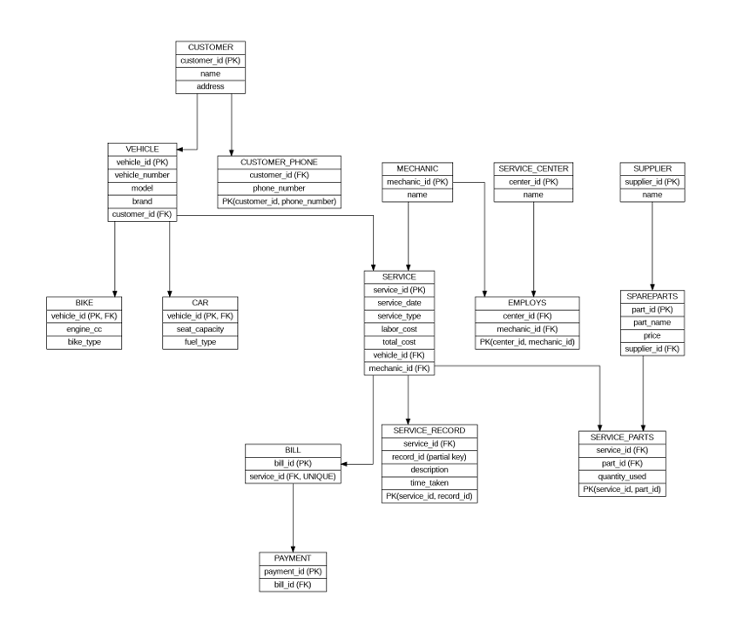

UNIVERSAL RELATION
UNIVERSAL_RELATION (
customer_id, customer_name, address, phone_number
vehicle_id, vehicle_number, model, brand,
engine_cc, bike_type, seat_capacity, fuel_type,
mechanic_id, mechanic_name,
center_id, center_name,
service_id, service_date, service_type, labor_cost, total_cost,
record_id, description, time_taken,
part_id, part_name, price,
supplier_id, supplier_name,
quantity_used,
bill_id, payment_id
)
ANOMALIES
Insertion anomalies:
(a) Cannot insert CUSTOMER alone
- You must also provide: vehicle_id, service_id
(b) Cannot insert VEHICLE without SERVICE
- Even if vehicle exists, you must insert: service details
(c) Cannot insert MECHANIC independently
- Needs: service_id
(d) Cannot insert SERVICE CENTER alone
- Must be linked with: mechanic or service
(e) Cannot insert SPARE PART alone
- Requires: service_id
(f) Cannot insert SUPPLIER alone
- Needs: part_id + service
(g) Cannot insert BILL / PAYMENT alone
- Need: service_id
Deletion anomalies
(a) Deleting SERVICE deletes everything
- Lose:
mechanic info
service record
spare parts used
bill + payment
(b) Deleting last SERVICE of a VEHICLE
- Vehicle info lost completely
(c) Deleting last VEHICLE of CUSTOMER
- Customer details lost
(d) Deleting SERVICE_PART entry
- lose: part info ,supplier info
(e) Deleting BILL
- Payment details also lost

Update anomalies
(a) Customer details repeated
- Name, address repeated for each service
(b) Vehicle details repeated
- Same vehicle appears in multiple services
(c) Mechanic name repeated
- Updating mechanic name requires multiple updates
(d) Service Center repeated
- Center name appears in many rows
(e) Spare part details repeated
- Same part stored multiple times
(f) Supplier details repeated
- Updating supplier name → multiple rows
FUNCTIONAL DEPENDENCIES
- customer_id → name, address
- customer_id, phone_number → phone_number (composite key)
- vehicle_id → vehicle_number, model, brand, customer_id
- model → brand (transitive — causes anomaly)
- mechanic_id → name
- center_id → name
- center_id, mechanic_id → (composite key)
- service_id → service_date, service_type, labor_cost, total_cost, vehicle_id, mechanic_id
- total_cost = labor_cost + parts_cost (derived — not stored)
- service_id, record_id → description, time_taken
- part_id → part_name, price, supplier_id
- supplier_id → name
- service_id, part_id → quantity_used
- bill_id → service_id
- payment_id → bill_id
1NF

- CUSTOMER
CUSTOMER (customer_id (PK),
name,
address)
- CUSTOMER_PHONE (multi-valued phone)
CUSTOMER_PHONE (customer_id (FK),
phone_number,
PRIMARY KEY (customer_id, phone_number)
)
- VEHICLE
VEHICLE (vehicle_id (PK),
vehicle_number,
model,
brand,
customer_id (FK)
)
- CAR
CAR (vehicle_id (PK, FK),
seat_capacity,
fuel_type
)
- BIKE
BIKE (vehicle_id (PK, FK),
engine_cc,
bike_type
)
- MECHANIC
MECHANIC (mechanic_id (PK),
name
)
- SERVICE_CENTER
SERVICE_CENTER (center_id (PK),
name
)
- EMPLOYS (relationship)
EMPLOYS (center_id (FK),
mechanic_id (FK),
PRIMARY KEY (center_id, mechanic_id)
)
- SERVICE
SERVICE ( service_id (PK),
service_date,
service_type,
labor_cost,
total_cost,
vehicle_id (FK),
mechanic_id (FK)
)

- SERVICE_RECORD
SERVICE_RECORD (service_id (FK),
record_id,
description,
time_taken,
PRIMARY KEY(service_id, record_id)
)

- SPAREPARTS
SPAREPARTS (part_id (PK),
part_name,
price,
supplier_id (FK)
)
- SUPPLIER
SUPPLIER (
supplier_id (PK),
name
)
- SERVICE_PARTS (multi-valued parts)
SERVICE_PARTS (service_id (FK),
part_id (FK),
quantity_used,
PRIMARY KEY (service_id, part_id)
)
- BILL
BILL (bill_id (PK),
service_id (FK UNIQUE))
- PAYMENT
PAYMENT ( payment_id (PK),
bill_id (FK)
)

ANOMALY CHECK AFTER 1NF
After converting to 1NF:
- Multi-valued attributes (phone_number, parts) are separated — basic insertion anomalies reduced.
- However, partial dependencies may still exist in tables with composite keys.
- Transitive dependencies still exist (model → brand in VEHICLE).
Conclusion: Anomalies not fully removed. Proceed to 2NF.

2NF
composite keys:
CUSTOMER_PHONE (customer_id, phone_number)
EMPLOYS (center_id, mechanic_id)
SERVICE_RECORD (service_id, record_id)
SERVICE_PARTS (service_id, part_id)
Customer_phone, employs, service_records,service_parts: already in 2nf
CUSTOMER, VEHICLE, CAR, BIKE, MECHANIC, SERVICE_CENTER, SERVICE, SPAREPARTS, SUPPLIER, BILL, PAYMENT: single PK ---2nf

ANOMALY CHECK AFTER 2NF
After checking 2NF:
  - No partial dependencies found in any composite-key table.
  - CUSTOMER_PHONE, EMPLOYS, SERVICE_RECORD, SERVICE_PARTS are all in 2NF.
  - Single-PK tables are automatically in 2NF.
  - However, transitive dependency remains: model → brand (in VEHICLE) and total_cost is derived.
Conclusion: Partial dependency anomalies removed. Transitive dependency anomalies remain. Proceed to 3NF.

3NF
[transitive dependency]

- VEHICLE Table
VEHICLE (vehicle_id, model, brand)

Dependency:
vehicle_id → model
model → brand
so; vehicle_id → brand (indirect)
therefore:
BRAND (brand_id PK, brand_name)
MODEL (model_id PK, model_name, brand_id FK)
VEHICLE (vehicle_id PK, vehicle_number,
model_id FK, customer_id FK)

- SERVICE Table
SERVICE(service_id, labor_cost, total_cost)
Dependency:
total_cost = labor_cost + parts_cost(derived)
so remove: total_cost

ANOMALY CHECK AFTER 3NF
After applying 3NF:
  - Transitive dependency model → brand resolved by creating BRAND and MODEL tables.
  - Derived attribute total_cost removed from SERVICE.
  - No partial dependencies, no transitive dependencies remain.
  - All insertion, deletion, and update anomalies are removed.
Conclusion: All anomalies removed. Normalisation stops at 3NF.

FINAL NORMALISED TABLES (3NF)

1. CUSTOMER (customer_id PK, name, address)
2. CUSTOMER_PHONE (customer_id FK, phone_number, PK(customer_id, phone_number))
3. BRAND (brand_id PK, brand_name)
4. MODEL (model_id PK, model_name, brand_id FK)
5. VEHICLE (vehicle_id PK, vehicle_number, model_id FK, customer_id FK)
6. CAR (vehicle_id PK FK, seat_capacity, fuel_type)
7. BIKE (vehicle_id PK FK, engine_cc, bike_type)
8. MECHANIC (mechanic_id PK, name)
9. SERVICE_CENTER (center_id PK, name)
10. EMPLOYS (center_id FK, mechanic_id FK, PK(center_id, mechanic_id))
11. SUPPLIER (supplier_id PK, name)
12. SPAREPARTS (part_id PK, part_name, price, supplier_id FK)
13. SERVICE (service_id PK, service_date, service_type, labor_cost, vehicle_id FK, mechanic_id FK)
14. SERVICE_RECORD (service_id FK, record_id, PK(service_id, record_id), description, time_taken)
15. SERVICE_PARTS (service_id FK, part_id FK, PK(service_id, part_id), quantity_used)
16. BILL (bill_id PK, service_id FK UNIQUE)
17. PAYMENT (payment_id PK, bill_id FK)

